How Much Do Auto Insurance Rates Vary By Age?

Data Crunch
Insurance #1

Annual Car Insurance Premiums By Age
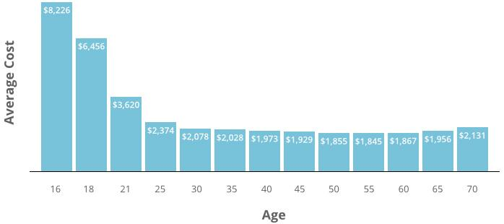

- Roughly how much more does auto insurance cost for a 16 year old compared to a middle aged (40-50 year old) driver?  DOK 1 | - Auto insurance rates drop consistently until a driver reaches what age?  DOK 1
- Why do you think that 16-18 year old drivers pay so much more for auto insurance?

DOK 2
- What does the chart indicate about the importance of driver experience when it comes to car accidents?

DOK 2
- What step do you think would have a greater impact on reducing the number of car accidents: a) Raise the driving age to 21 OR b) Take away driver’s licenses at the age of 65.

DOK 3

